Size of int in typical architecture is 4 bytes so 32 bits
first bit for sign 1- (neg sign) (0-pos sign) for signed int

range of int: -2^31 to 2^31-1
size of pointer in typical architecture is also 4bytes.

Linked list:

in c:

struct Node{
int data;
struct Node *next;
};

int main(){
Node *head=(Node*)malloc(sizeof(Node));
*head.data=2;
printf(“%d\n”,head->data);
return 0;
}

if you want to delete a node in c: free(head)

in c++:

struct Node{
int data;
Node *next;
};

int main(){
Node *head=new Node();
*head.data=2;
printf(“%d\n”,head->data);
return 0;
}
and if you want to run in terminal
g++ -Wall -o memoryalloc memoryalloc.cpp

./memoryalloc

if you want to delete a node in c++: delete (head)

one more method of passing head to a function as a reference so that it will also keep modifying also without returning

void insert (Node ** pointerToHead,int x)
{

}
insert(&head,5)
so something to keep in mind ***important*** passing pointer is complicated, https://www.youtube.com/watch?v=cAZ8CyDY56s&list=PL2_aWCzGMAwI3W_JlcBbtYTwiQSsOTa6P&index=6 from 10:20 to end

new info about memory classification:
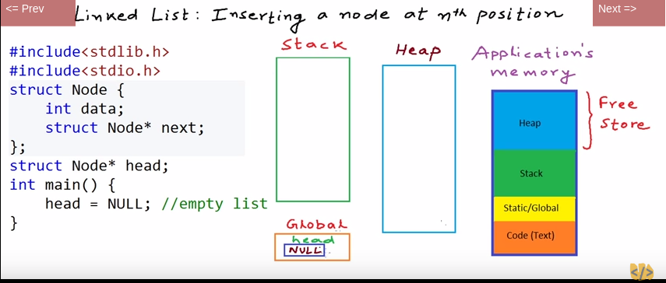

video 8: delete a node at nth position

video11: reverse a link a list using recursion

with global head it’s easy .

Try it without global head
done and dusted!

Video 12: doubly link list

video 13:
doubly link list implementation
like insert reverse

video14 : introduction to stacks : is an abstract data type(adt). We know features and operations. We dont talk about implementation.
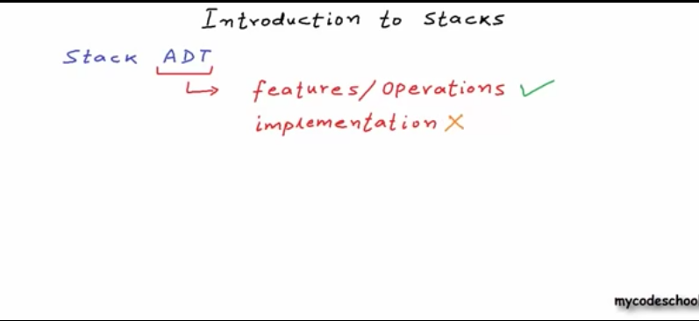
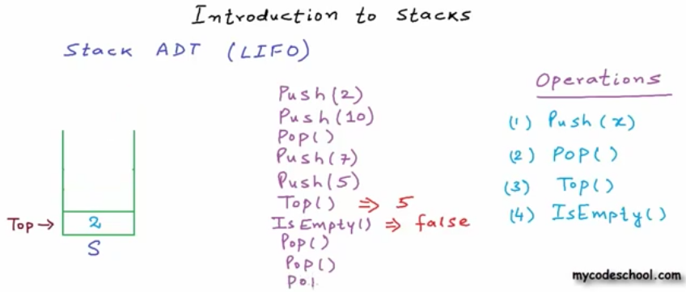

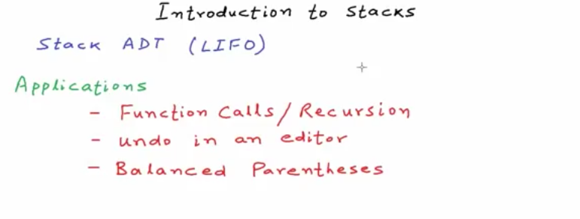

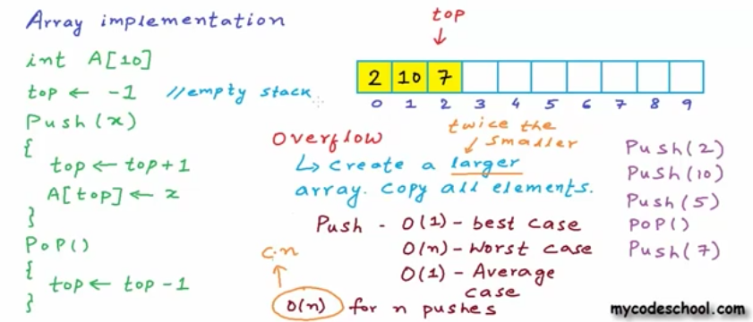

Video16: stack linked list

AVL Tree:

